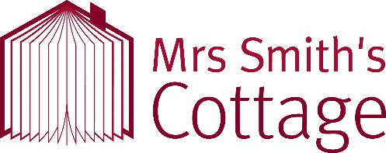
School Visit Booking Form
Thank you for your interest in a visit to Mrs Smith’s Cottage.
We for one class of 30 pupils we charge £142 for a half day (3 workshops) and £251 for a full day (6 workshops). The balance can be paid by cheque or card ahead of time.
School Name: |  | Address: |  |  |  | Postcode:
 |  |  |  |  |  | Phone:
Primary Contact | Name: |  |  | Email:
 | Position: |  |  | Phone:
Date of Visit: |  | Arrival Time: |  |  | Departure Time:
Number of Pupils: |  | Number of Staff: |  |  | Number of 1-to-1 support staff:
Requested Topic (see Topic and Activity list)
Requested Workshops and Activities (see Topic and Activity list)
Total charge for visit:
Where did you hear about our learning programme?
Primary Contact Signature: |  |  | Date Signed:
Please complete and return to – mrssmithscottage@n-kesteven.gov.uk
For Office Use | Booking Confirmed: |  | Booking Paid: |  | Signed:

