Rainbow Walk

Mrs Smith liked to stay active, she never owner a car and often went on walks in the local area (and when on holiday). This activity will give you a focus for your daily walk, helping you to discover more about your local area and how it changes through the seasons.
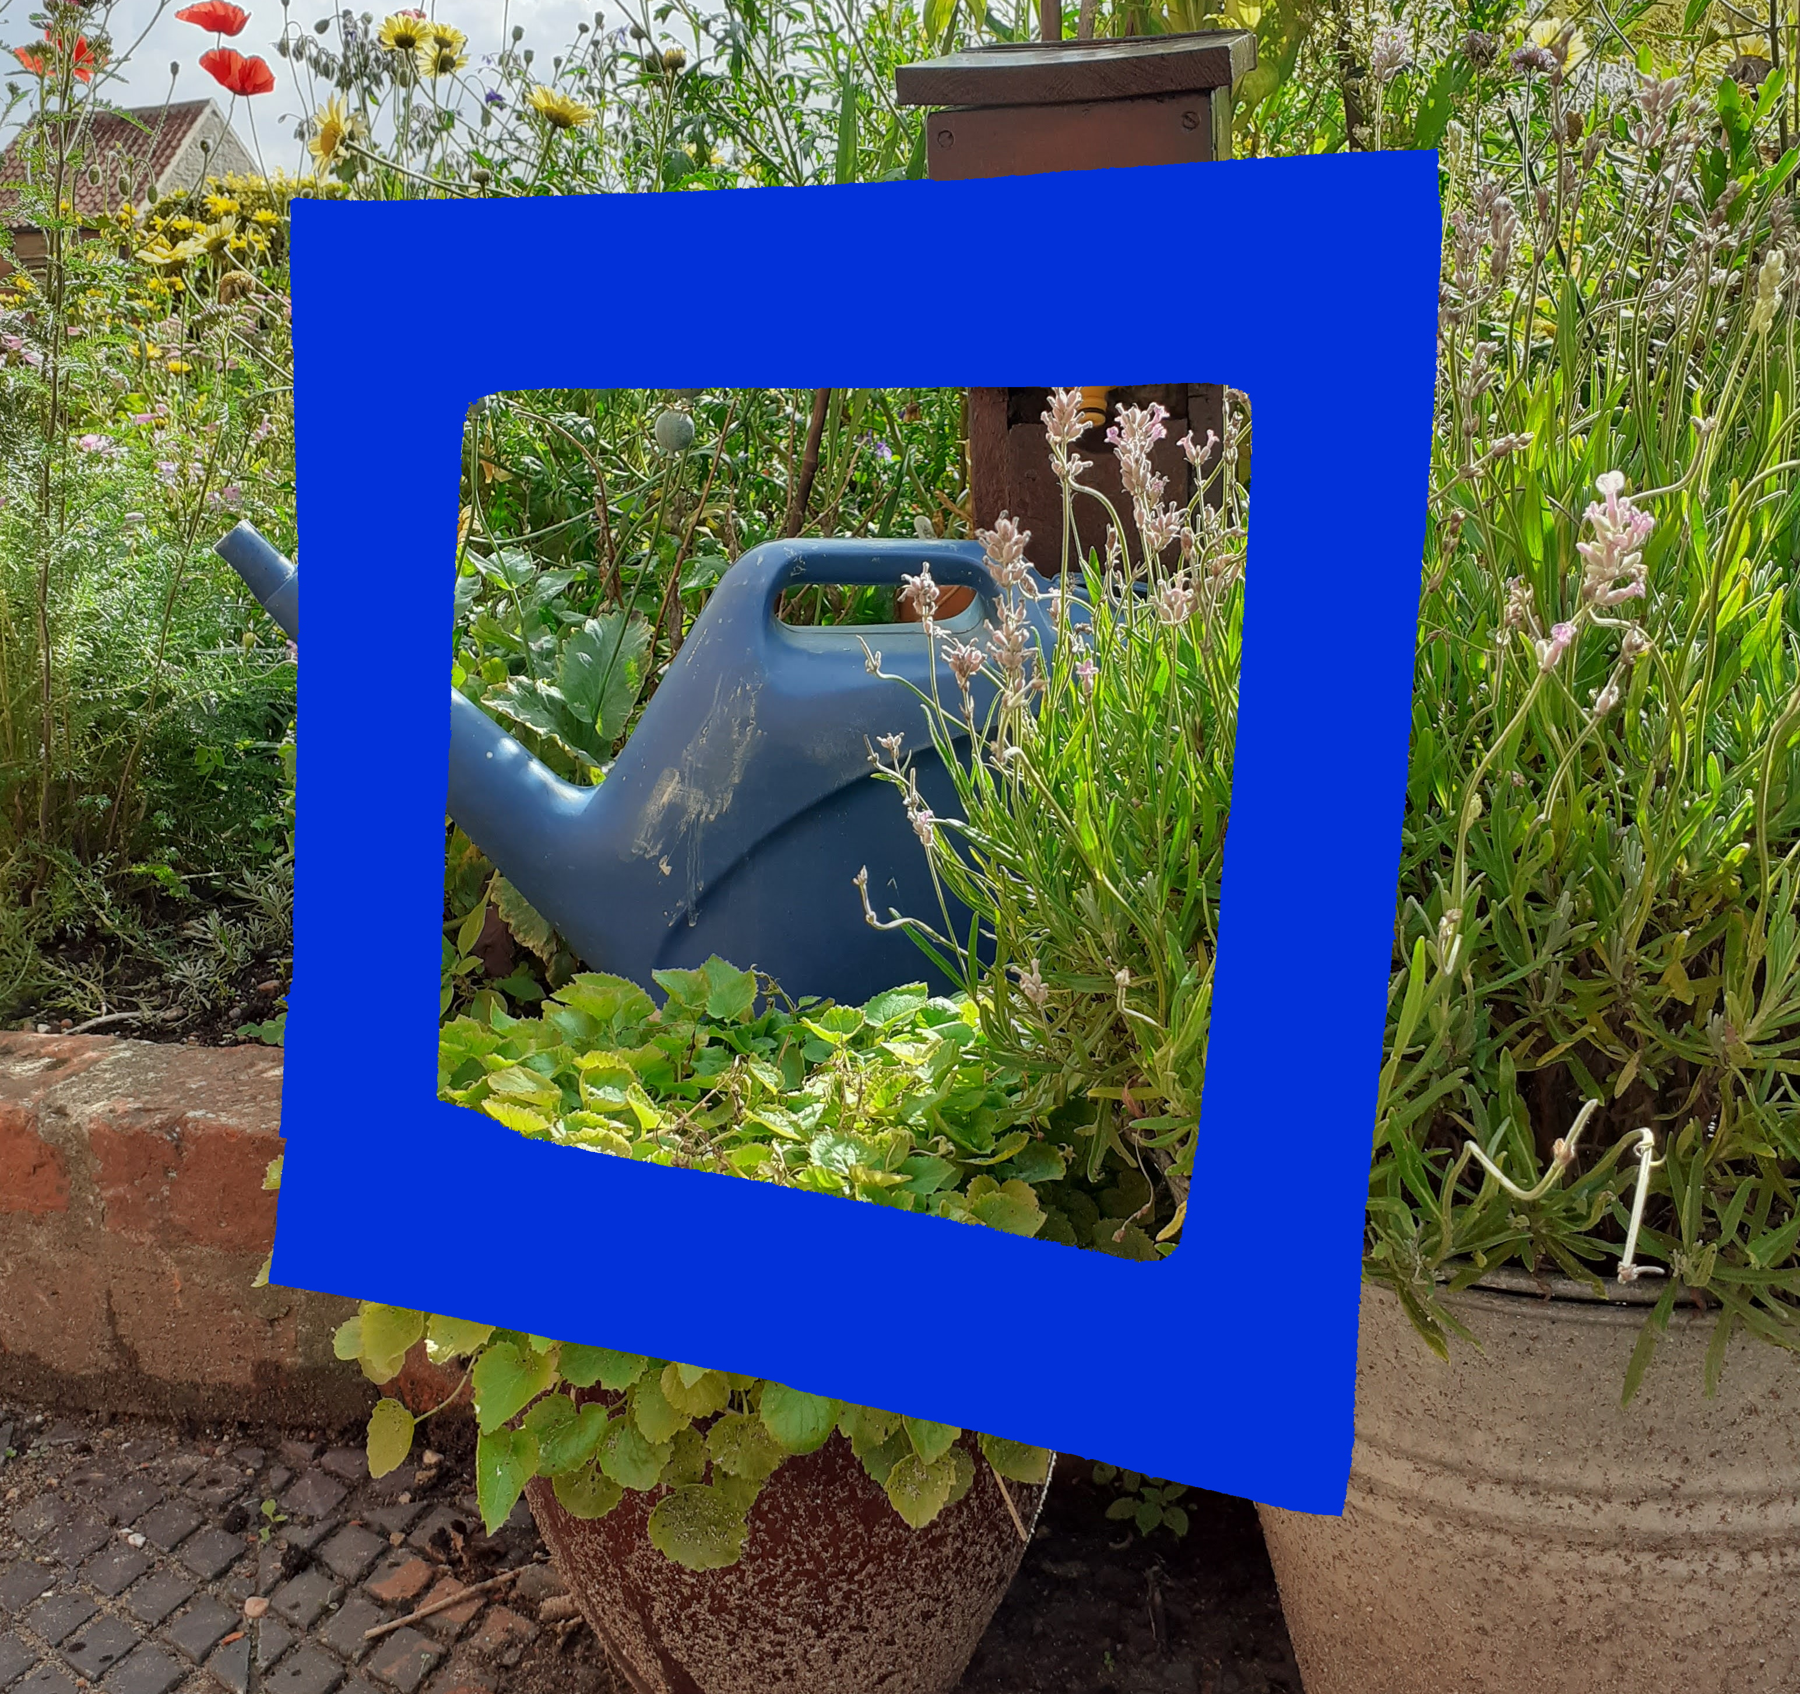
You will need:  - Paper or Card  - Coloured Pens/Pencils or Paint  - Scissors  - A route to walk  - A camera  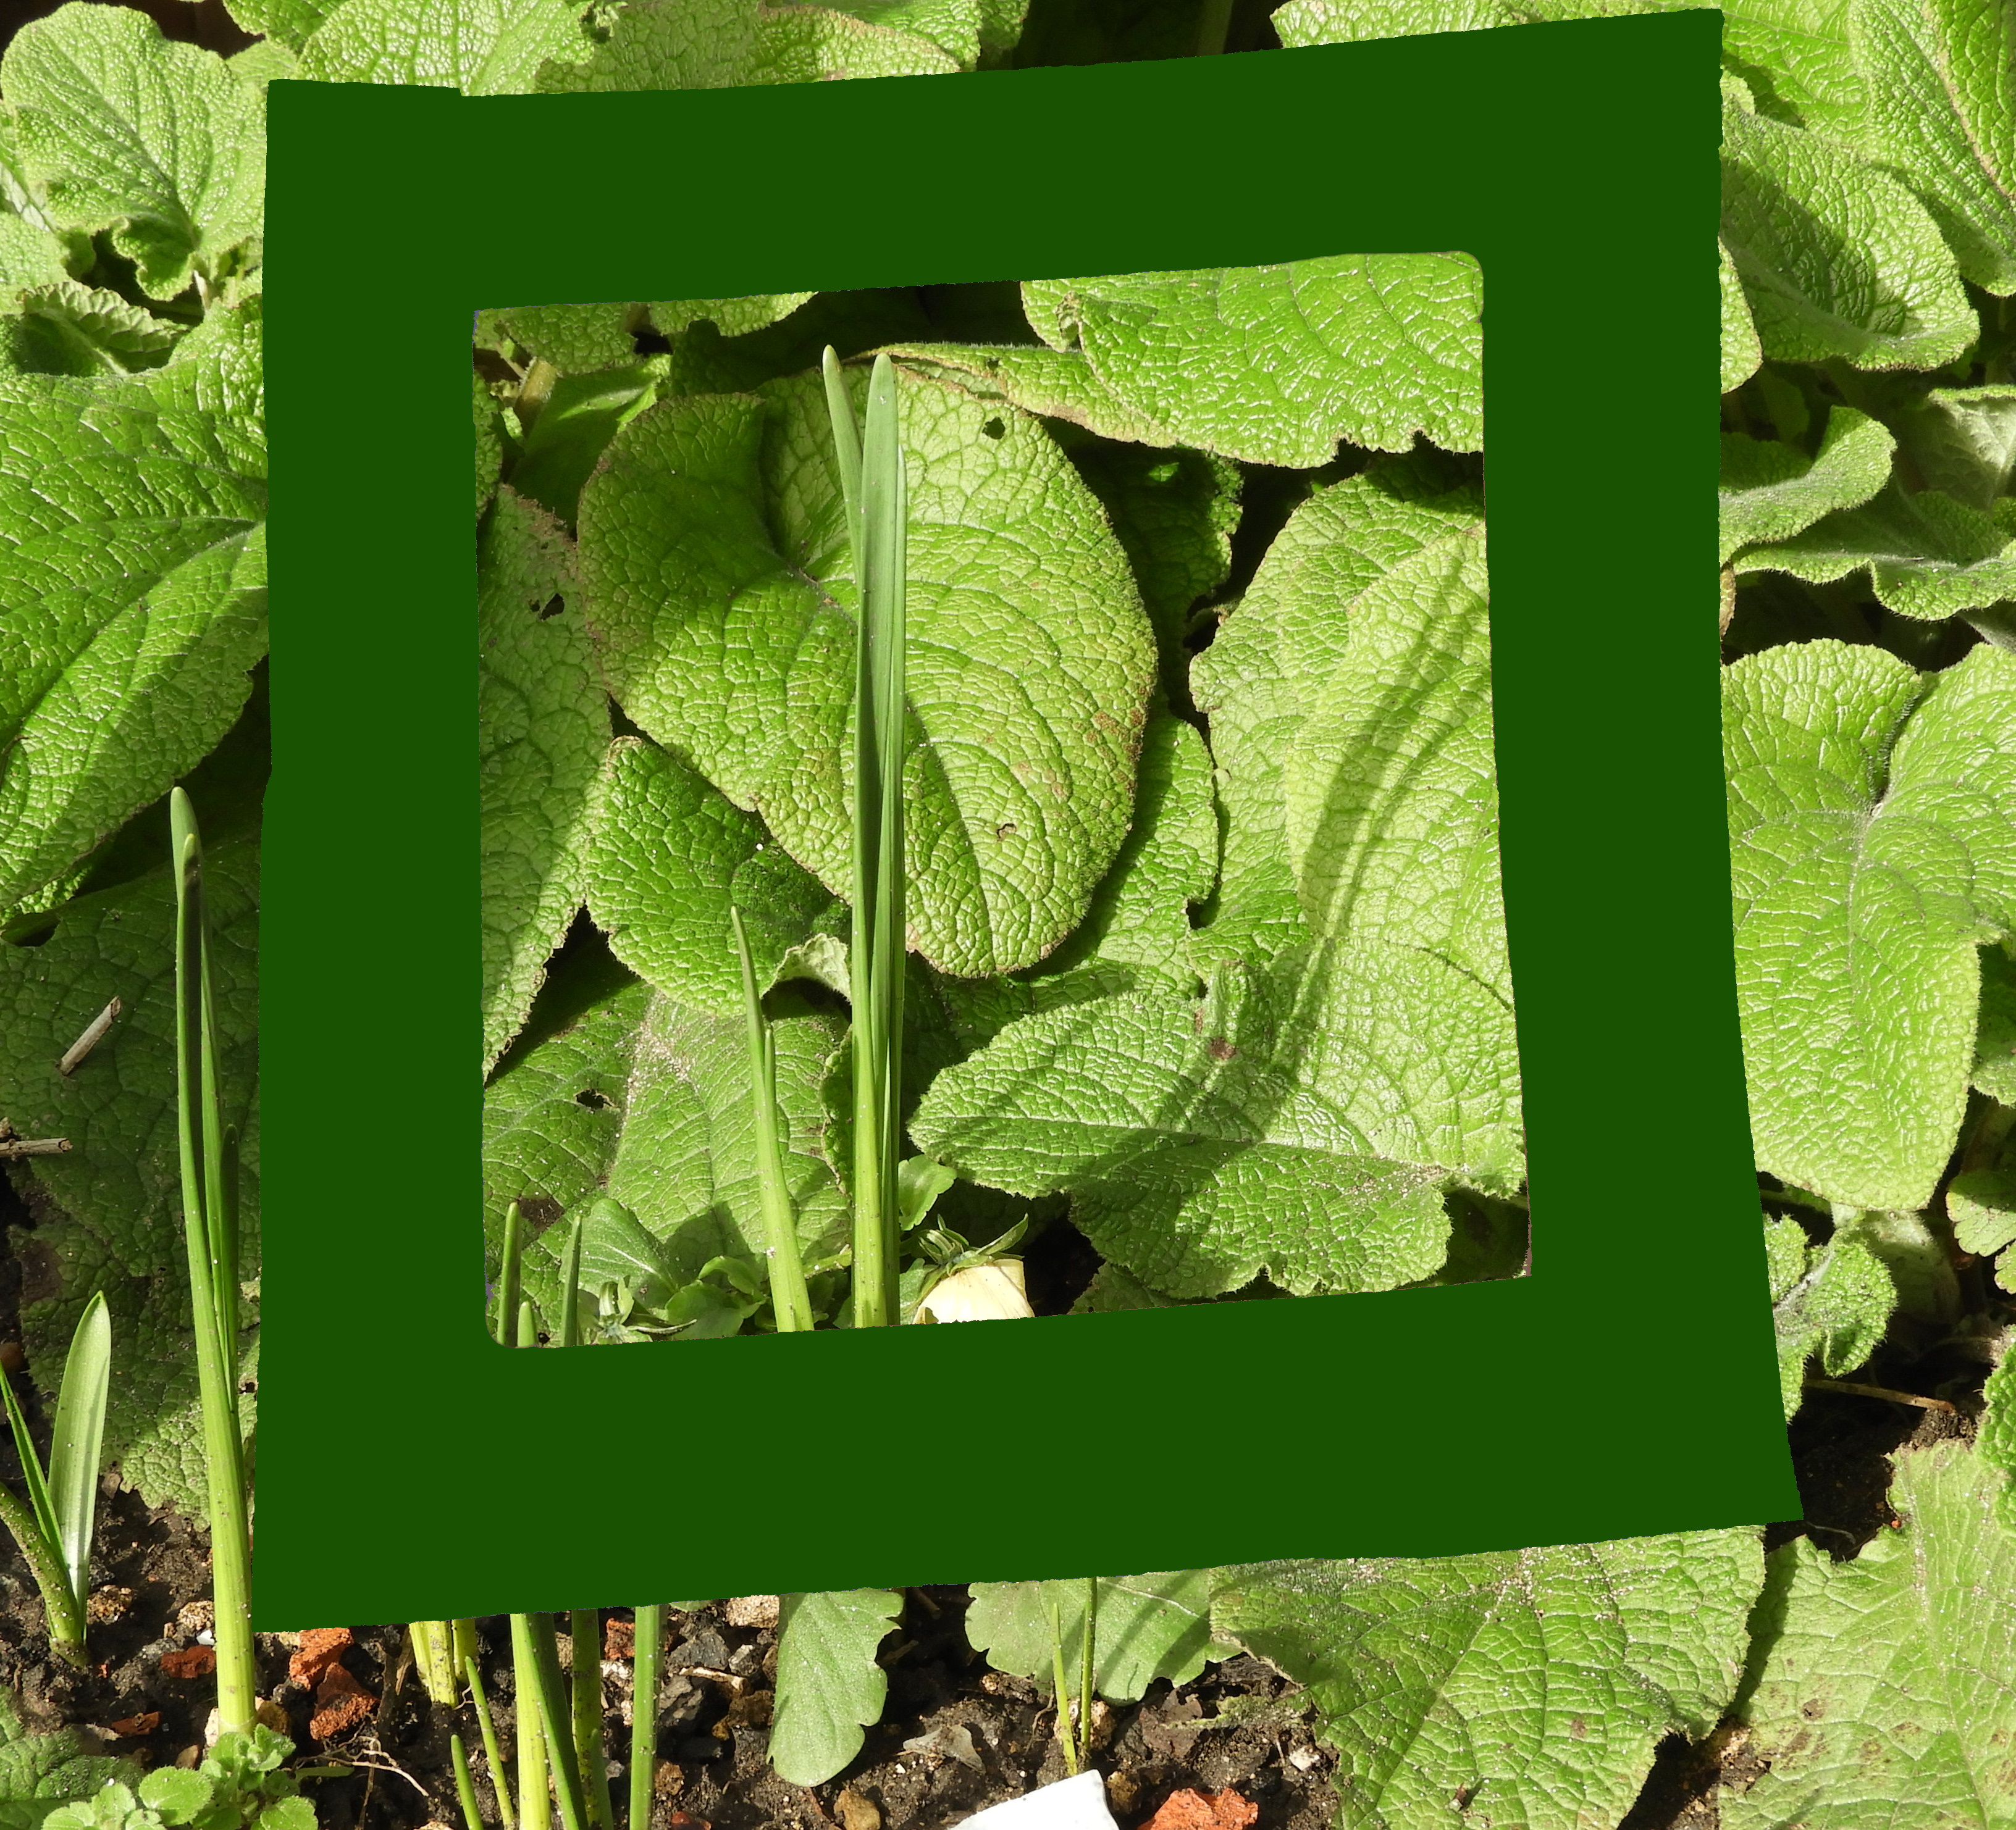 | Preparing for your walk:  - On a piece of paper or card draw and cut out 7 small frames, they can be any shape you want.  - Colour each frame with a different colour of the rainbow!  - Plan a route, wrap up warm, and charge your camera/phone  On your walk try to find something of each colour of the rainbow.  When you have found a colour take a photograph, using the frame of the same colour to highlight the thing you have found!  Share your rainbow with us on Twitter or Instagram using #NKRainbowWalk or if you are on Facebook send them to the Heart of Lincs page.
