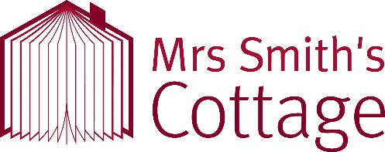
School Visit Booking Form
Thank you for your interest in a visit to Mrs Smith’s Cottage.
We charge £2 per child per workshop, with supporting adults visiting at no additional cost. See our topics and workshops list to select the offer which is right for you. The trip is to be paid for ahead of time by cash, cheque, or card.
School Name: |  | Address: |  |  |  | Postcode:
 |  |  |  |  |  | Phone:
Primary Contact | Name: |  |  | Email:
 | Position: |  |  | Phone:
Date of Visit: |  | Arrival Time: |  |  | Departure Time:
Number of Pupils: |  | Number of Staff: |  |  | Number of 1-to-1 support staff:
Requested Topic (see Topic and Activity list)
Requested Workshops and Activities (see Topic and Activity list)
Total charge for visit:
Where did you hear about our learning programme?
Primary Contact Signature: |  |  | Date Signed:
Please complete and return to – mrssmithscottage@n-kesteven.gov.uk
For Office Use | Booking Confirmed: |  | Booking Paid: |  | Signed:

